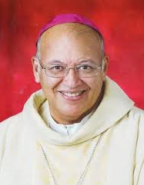

Archbishop Robert Rivas, [O.P.](http://www.gcatholic.org/orders/005.htm)



**Archdiocese of Castries**   
Archbishop's House  
Castries St. Lucia

Archbishop Robert Rivas has after discussions with Glenda La Fleur 21 November 2013 approved that the Living Rosary can be introduced in congregations and religious associations throughout St. Lucia.